If you have copied the web address of different websites and pasted them on a word document, it is shown with blue font colour and underline then how will you remove it?
All of the mentioned options
By removing hyperlink
By using conditional formatting
By using text formatting options
None of these
B) By removing hyperlink
To remove the hyperlink formatting from the web addresses, you can either use the "Ctrl + Shift + F9" keyboard shortcut or right-click on the hyperlink and choose "Remove Hyperlink" from the context menu. This will convert the hyperlinked text back to plain text without the blue font color and underline.
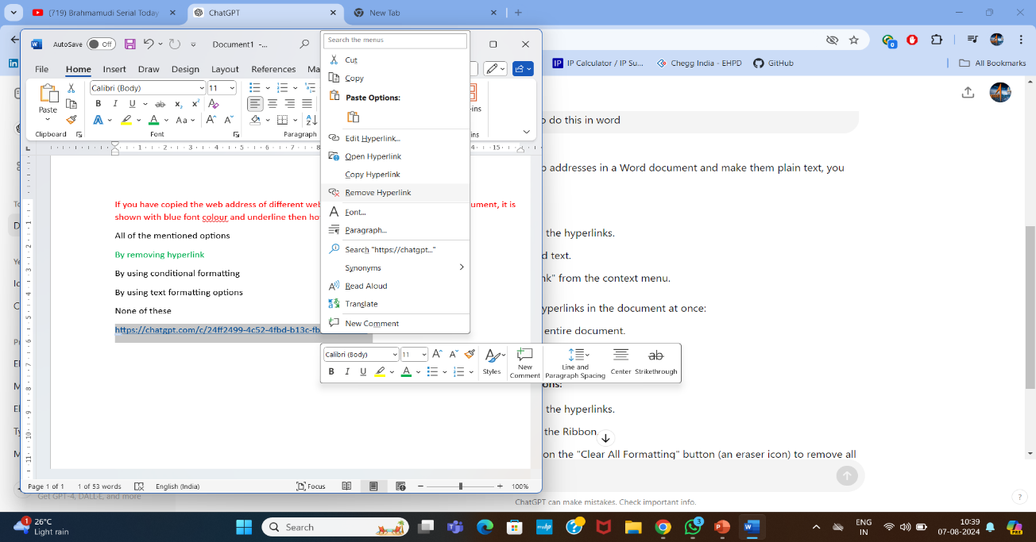
If you want to start the presenter view from the current slide in PowerPoint then, which of the following key you should press?
F5
Ctrl+F5
Shift+F5
Alt+F5
None of these
F5: Starts the slideshow from the beginning.
Ctrl+F5: This combination doesn't have a default function in PowerPoint.
Shift+F5: Starts the slideshow from the current slide.
Alt+F5: Starts the Presenter View from the current slide.
None of these: Not applicable as the other options are correct.
In which of the following application you can not run spellcheck ?
MS word
Notepad
Powerpoint
Ms excel
None of these
MS Word: Spellcheck is available.
PowerPoint: Spellcheck is available.
MS Excel: Spellcheck is available.
Notepad, there is no built-in spellcheck functionality.
In which of the following application you can save the document as PDF ?
All of the mentioned options
Ms word
Ms powerpoint
Ms excel
None of these
MS Word: In Microsoft Word, you can save the document as a PDF directly from the application. Go to the "File" menu, then select "Save As," and choose "PDF" from the list of available file formats. This will save the Word document as a PDF file.
MS Excel: In Microsoft Excel, you can also save the spreadsheet as a PDF. Similar to MS Word, go to the "File" menu, then select "Save As," and choose "PDF" as the file format.
MS PowerPoint: In Microsoft PowerPoint, you can save the presentation as a PDF file. Go to the "File" menu, then select "Save As," and choose "PDF" from the available file formats.
In Office Suite, which of the following key with Ctrl (modifier key) is used to replace text?
H
P
D
R
None of these
Ctrl + H: Opens the "Find and Replace" dialog box (specifically the Replace tab).
Ctrl + P: Opens the Print dialog or Print Preview.
Ctrl + D: Opens the Font dialog box.
Ctrl + R: Aligns the text to the right
In Windows operating system, Ctrl + R works similar to which of the following key?
F2
F8
F5
F3
None of these
F2: Rename the selected item.
F3: Search for a file or folder.
F5: Refresh the current window or page.
F8: Access advanced startup options (mainly during boot).
In MS Word, which of the following is used to set the margins of the page?
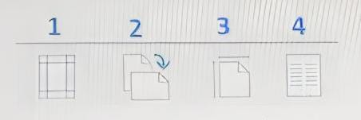
1
3
4
2
None of these
Answer is 1.it is located in MS word---layout
In Gmail, which of the following is used to mark a mail as read?
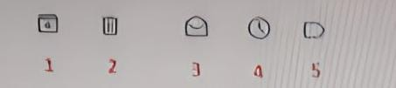
1
3
4
2
None of these
If you apply the formula given in the formula bar in cell D1 then what would be the answer?
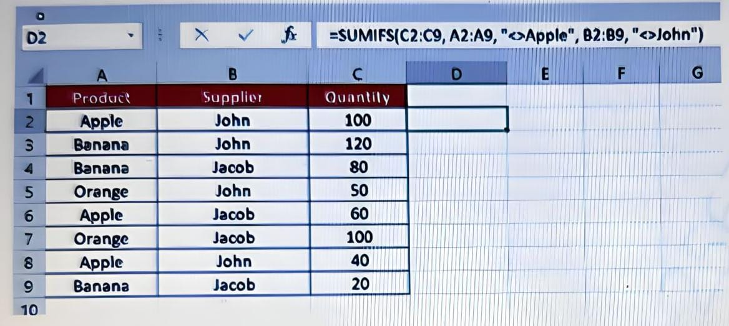

200
240
120
260
None of these
C2:C9: This is the sum range. It specifies which cells contain the values that will be summed if the criteria are met.
A2:A9: This is the first criteria range. It defines the cells to be evaluated against the first condition ("<>Apple").
"<>Apple": This is the first criteria. It means "not equal to Apple". The function will only include values from the sum range (C2:C9) where the corresponding cell in the first criteria range (A2:A9) does not contain "Apple".
range of cells (e.g., B2:B9) that aligns with the row numbers in your dataset.
<>John": This is the second criteria. It means "not equal to John". The function will include values from the sum range (C2:C9) only where the corresponding cell in the second criteria range (which should align with 82:89, but this is incorrect) does not contain "John".
This formula sums the values in C2:C9 where:
- The product in A2:A9 is not "Apple". =150+200+120+130=600
- The supplier in B2:B9 is not "John". =200+80+130=410
- Total sum=600+410=1010

If you will apply the formula shown in the formula bar in cell G1 then what would be the answer?
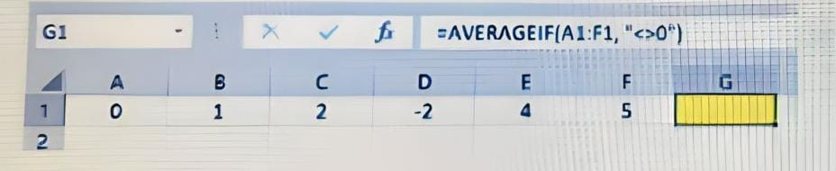
2
1.5
1.66
3
None of these
Exclude zeroes: 0 is excluded.
Remaining values: 1, 2, -2, 4, 5.
Calculate the average:
- Sum of remaining values: 1 + 2 + (-2) + 4 + 5 = 10
- Number of remaining values: 5
- Average: 10 / 5 = 2
In PowerPoint presentation, which of the following is used for slide sorter view?
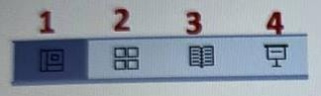
1
3
4
2
None of these
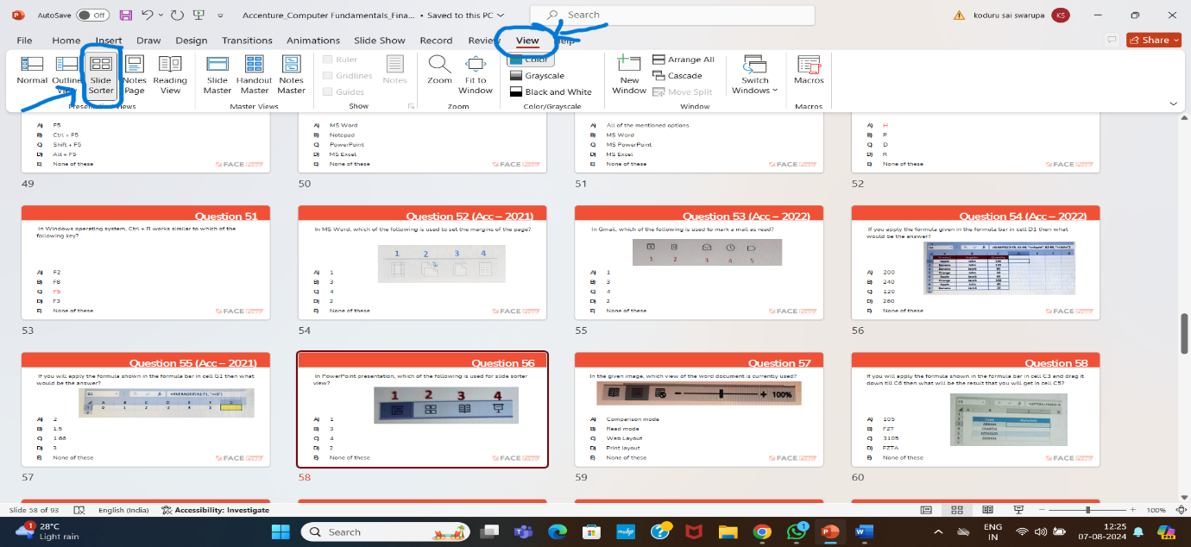
In the given image, which view of the word document is currently used?

Comparison mode
Read mode
Web layout
Print layout
None of these
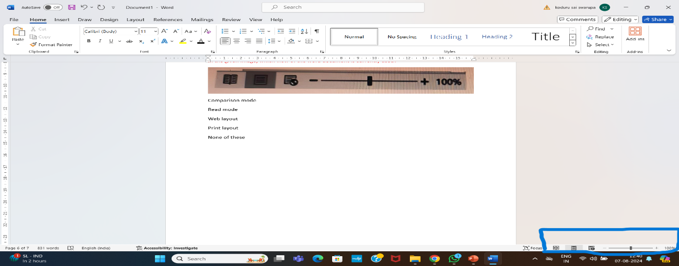
If you will apply the formula shown in the formula bar in cell C3 and drag it down till C6 then what will be the result that you will get in cell C5?
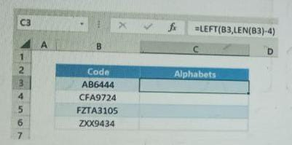
105
FZT
3105
FZTA
NONE OF THESE
Given that cell B5 contains the text FZTA3105 and you apply the formula =LEFT(B5,LEN(B5)-4), let’s break down what happens:
- LEN(B5): This calculates the length of the text in B5. For FZTA3105, the length is 8 characters.
- LEN(B5)-4: This subtracts 4 from the length, giving 8 - 4 = 4.
- LEFT(B5, LEN(B5)-4): This extracts the first 4 characters from the text in B5.
So, applying the formula =LEFT(B5, 4) to FZTA3105 will give you the first 4 characters, which are FZTA.
Thus, the result in cell C5 will be FZTA.
In MS Word, which of the following should be used for decreasing the indent?
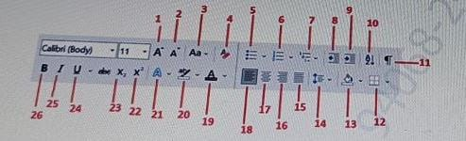
9
7
14
8
None of these
In MS Excel, which of the following symbol with Ctrl+Shift is used to change the cell format to General?
~
@
^
#
None of these

In MS Excel, the symbol used with "Ctrl + Shift" to change the cell format to General is the tilde (~) key.
In MS Word, if you have to indent the paragraph then which of the following shortcut key you should use?
Ctrl+I
Alt+M
Ctrl+M
Alt+I
None of these
Ctrl + M
Increase Indent: Press the "Ctrl + M" keys on your keyboard to increase the indent of the paragraph. Each time you press "Ctrl + M," the paragraph's indentation will increase.
Decrease Indent: Press the "Ctrl + Shift + M" keys on your keyboard to decrease the indent of the paragraph. Each time you press "Ctrl + Shift + M," the paragraph's indentation will decrease.
Ctrl + I:
- Function: Italicizes the selected text.
Alt + M:
- Function: Opens the Mailings tab in the Ribbon (if using certain versions of Word).
Alt + I:
- Function: Opens the Insert tab in the Ribbon (in some versions of Word).
While checking a word document, if you find double blue lines under a/the word(s) then what does it indicates?
1. Spelling error
2. Double space between words
3. wrong letter case
The double blue lines, also known as wavy blue lines, are used by Microsoft Word to indicate potential spelling errors in the document. When Word detects a word that it doesn't recognize or that doesn't match its built-in dictionary, it underlines the word with these wavy blue lines to signal a possible spelling mistake. The purpose is to alert the user to review the word and potentially correct it if it is indeed misspelled.
Identify the application from the given icon
Google slides
MS excel
MS teams
Google sheets


From the given image of MS word ruler identify the symbol for first line indent setting ?
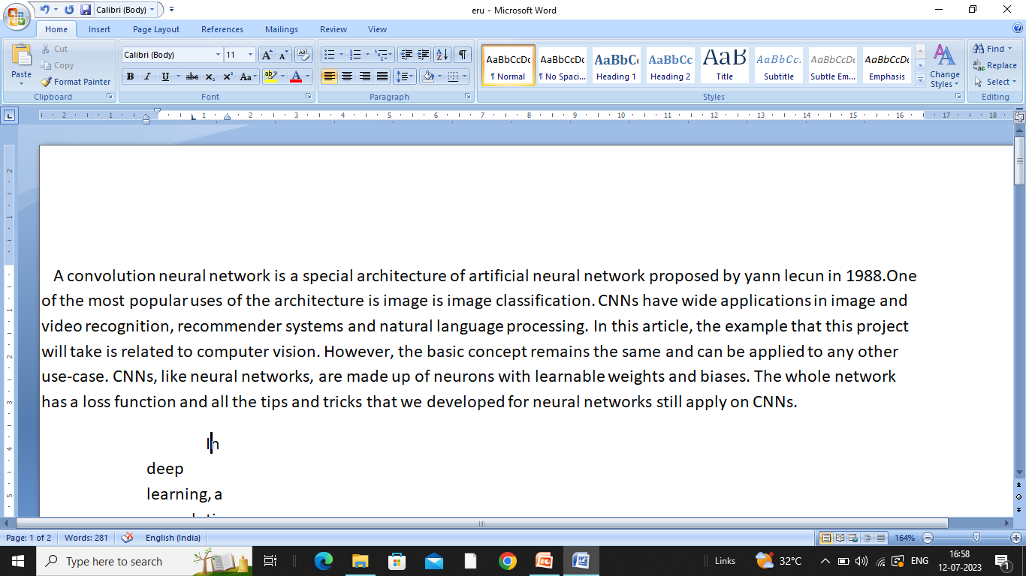
The symbol for the first line indent setting in the MS Word ruler is a small, downward-facing arrow. It appears on the horizontal ruler and is used to adjust the indentation of the first line of a paragraph
While using paint application, which of the following action you can not perform?
Rotating an image at an angle of 90 degree
Rotating an image at an angle of 45 degree
Flipping an image vertically
In the Paint application, you have the option to rotate an image at an angle of 90 degrees (clockwise or counterclockwise) using the "Rotate" tool from the "Image" tab. Additionally, you can flip an image vertically using the "Flip vertical" option also found in the "Image" tab.
68. In the given example of a URL with different components, which of the following is a Second Level Domain?
In the context of URL components, the Second Level Domain (SLD) is the part of the domain name that is directly to the left of the Top Level Domain (TLD). For example, in the URL https://www.example.com, the domain name is example.com, where:
- Top Level Domain (TLD): .com
- Second Level Domain (SLD): example
So, in the URL https://www.example.com, example is the Second Level Domain.

69. In Gmail, which of the following icon is used to move an email from one folder to another?
• Open Gmail and find the email you want to move.
• Select the email by clicking the checkbox next to it.
• At the top of the Gmail interface, you will see several icons. Click on the folder icon with a rightward arrow (this is the “Move to” icon).
• A dropdown menu will appear with a list of folders (labels) you can move the email to. Select the desired folder.
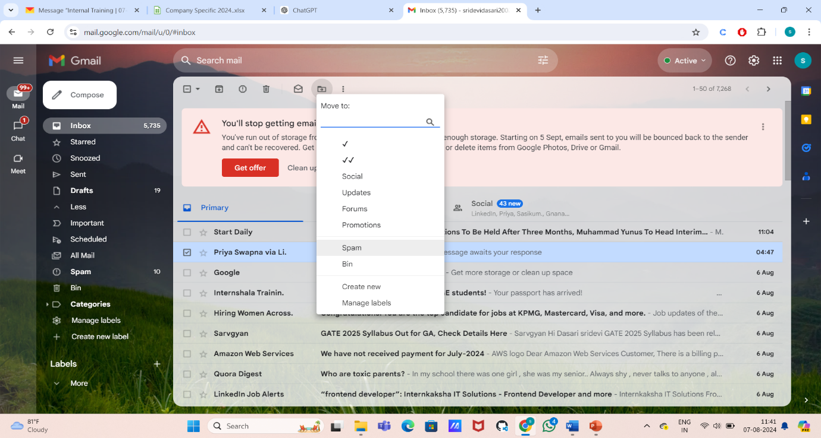
70. Which of the following is the default AI assistant for Macintosh operating system
The default AI assistant for the macOS operating system is Siri. Siri is Apple's voice-activated virtual assistant that helps with tasks such as setting reminders, sending messages, searching the web, and more.
• Activate Siri: Click the Siri icon in the menu bar (a small circle with a wave-like design) or use the keyboard shortcut (usually Cmd + Space).

• Ask a Question: Once Siri is activated, you can ask a question or give a command. For example, say or type, “What’s the weather today?”
• Get a Response: Siri will then provide you with the current weather information for your location.
Function: Alexa is Amazon’s virtual assistant designed to control smart home devices, play music, set reminders, and provide news and weather updates.
• Function: Developed by Microsoft, Cortana was designed to assist with reminders, calendar management, and searching for information. It is integrated into the Windows operating system but has been scaled back to focus more on productivity in Microsoft 365.
• Example: On a Windows 10 PC, you can say, “Hey Cortana, open Microsoft Word.” Cortana will then launch Microsoft Word for you.
71. In MS Word, which of the following feature is used to redcue spelling error in the document?
Example Scenario
Suppose you frequently mistype the word “accommodate” as “accomodate.”
Setting Up AutoCorrect
- Open Microsoft Word.
- Go to the "File" tab (or the "Office" button in some versions) and select "Options".
- In the Word Options window, click on "Proofing" in the left sidebar.
- Click on the "AutoCorrect Options" button.
- In the AutoCorrect window, you will see a list of common spelling mistakes and their corrections.
Adding an AutoCorrect Entry
- In the "Replace" field, type your common misspelling, such as "accomodate."
- In the "With" field, type the correct spelling, such as "accommodate."
- Click "Add" to add this entry to the list.
- Click "OK" to close the AutoCorrect Options window, and then click "OK" again to close the Word Options window.
How It Works
When you type “accomodate” in your document, AutoCorrect will automatically change it to “accommodate” as soon as you press the spacebar or punctuation key.
Practical Use
If you were writing a document and mistyped “accomodate”:
- As soon as you complete the word and move on (e.g., by pressing the spacebar or punctuation), Word would automatically correct it to “accommodate.”
This feature helps you avoid repetitive spelling mistakes and ensures consistent spelling throughout your document.
• Smart Tags: These are used for recognizing and handling specific types of data in your document, like names or dates, but they are not primarily used for spelling correction.
• AutoText: This feature allows you to create shortcuts for frequently used text, so you can insert it quickly, but it doesn’t correct spelling errors.
• AutoFormat: This feature automatically formats your text as you type, such as applying styles or changing the format of text, but it does not correct spelling errors.
• AutoCorrect: This feature automatically corrects common spelling mistakes as you type. For instance, if you type "teh," AutoCorrect will automatically change it to "the."
72. In MS Word, which of the following modifier key is used with backspace to delete the entire word on the left of cursor?
Function with Backspace: The Alt key does not have a function when combined with Backspace for deleting text.
Function with Backspace: Shift does not have a specific function with Backspace for deleting entire words. Pressing Shift + Backspace simply deletes a single CHARECTERleft of the cursor.
Function with Backspace: Tab does not combine with Backspace for text deletion. Tab + Backspace is not a recognized text-editing shortcut in Word.
in Microsoft Word, to delete the entire word to the left of the cursor using a modifier key with Backspace, you use the "Ctrl" key.
How It Works
- Press and hold the "Ctrl" key.
- **While holding the "Ctrl" key, press "Backspace."
This action deletes the entire word to the left of the cursor position, rather than just a single character.
73.While composing an email using Gmail, which of the following is used to insert files using drive?
- Compose a New Email:
  - Click on the "Compose" button in Gmail to start a new email.
- Click on the "Drive" Icon:
  - At the bottom of the email composition window, you’ll see several icons. Click on the "Drive" icon, which looks like a triangle made up of three colors (blue, green, and yellow).
- Select Files from Google Drive:
  - A dialog will appear showing your Google Drive files. Navigate to the file you want to insert.
- Choose How to Insert:
  - You can choose to either "Insert as Drive link" or "Attach as a copy."
    - Insert as Drive link: This will include a link to the file in your email. The recipient will need permission to access the file in Drive.
    - Attach as a copy: This will attach a copy of the file to the email, so the recipient doesn’t need access to the original file in Drive.
- Send the Email:
  - After inserting the file, you can continue composing your email and then click "Send" when ready.
This method helps integrate Google Drive with Gmail, allowing for easy sharing of files stored in your Drive.
74.If you use NOW function in MS Excel then it will return -
I. Current time
II. Current date

In Microsoft Excel, the NOW function returns both the current date and time.
So, if you use the NOW function, it will return:
I. Current time
II. Current date
The function provides a timestamp that includes both the date and the time. For example, if the current date and time is August 7, 2024, 3:45 PM, the NOW function will display something like 8/7/2024 15:45 depending on your regional date and time format settings.
=now()
75.If by accident a mail is deleted then, which of the following folders can be used to recover the same?
If an email is accidentally deleted in Gmail, you can recover it from the "Trash" folder. Here’s how:
- Go to Gmail: Open your Gmail account.
- Navigate to the "Trash" Folder:
  - On the left sidebar, scroll down and find the "Trash" folder. You might need to click "More" to expand additional folder options.
- Locate the Deleted Email:
  - In the Trash folder, look for the email you accidentally deleted. You can use the search bar to help locate it if you have many emails in the Trash.
- Restore the Email:
  - Once you find the email, select it by checking the box next to it.
  - Click on the "Move to" icon (folder icon) and select "Inbox" or any other folder where you want to restore it.
Important Notes:
- Emails in Trash are automatically deleted after 30 days, so it’s best to recover them as soon as possible.
- If the email is not in the Trash, it might have been permanently deleted or moved to the "Spam" folder, where you should also check if it was mistakenly marked as spam.
Using the Trash folder is the primary way to recover emails that have been accidentally deleted but are still within the retention period.
76.
Which of the following can be formed if we connect personal computers?A)B)C)D)SupercomputerEnterpriseNetworkServe
Network
Here’s a brief explanation of why the other options don’t fit:
- Supercomputer: This refers to a highly powerful computer designed for complex calculations and processing tasks. It’s not related to simply connecting personal computers.
- Enterprise: This term usually refers to a large organization or business, not a type of network formed by connecting personal computers.
- Server: A server is a specialized computer that provides resources or services to other computers (clients) on a network. It’s part of a network but not a type of network itself.
Connecting personal computers creates various types of networks, such as a Local Area Network (LAN), Home Network, or Peer-to-Peer Network, depending on the configuration and purpose.
Which option is used to translate the selected content in MS Word?A)B)C)D)Translate SelectionTranslate to LanguageTranslate Selected TextTranslate the Content
In Microsoft Word, the option used to translate the selected content is:
A) Translate Selection
Here’s a brief overview of how to use this feature:
- Select the Text:
  - Highlight the text you want to translate.
- Go to the "Review" Tab:
  - Click on the "Review" tab in the Ribbon.
- Click on "Translate":
  - In the Language section, click on "Translate".
- Choose "Translate Selection":
  - From the drop-down menu, select "Translate Selection". This will open the Research pane where you can choose the language to which you want to translate the selected text.
Microsoft Word uses built-in translation tools or integrates with Microsoft Translator to provide translation services for your selected text.
Which of the following is the type of connection that helps us navigate from one slide to another slide in the same presentation and to a slide in another presentation?
C) Hyperlink
How to Use Hyperlinks in PowerPoint:
- Select the Text or Object:
  - Highlight the text or select the object (such as a shape or image) that you want to use as a hyperlink.
- Insert the Hyperlink:
  - Right-click on the selected text or object and choose "Link" or "Hyperlink" from the context menu. Alternatively, you can go to the "Insert" tab on the Ribbon and click on "Link".
- Choose the Link Destination:
  - In the "Insert Hyperlink" dialog box, you can:
    - Link to a Slide in the Same Presentation: Choose "Place in This Document" and select the slide you want to link to.
    - Link to Another Presentation: Choose "Existing File or Web Page" and browse to the other presentation file.
    - Link to a Web Page or Document: Enter the URL or browse to the document.
- Apply the Hyperlink:
  - Click "OK" to apply the hyperlink.
Using hyperlinks, you can create interactive presentations that allow you to jump between slides or even to other presentations and external resources.
How would you insert the international character shown in the image given below?
CTRL + SHIFT + ALT + [Character]: This combination is sometimes used for special characters, but it is not universally applicable to all international characters.
Which of the following can be used to close a tab on a browser?

To close a tab in a browser, you can use the following methods:
- Mouse Click:
  - Click on the "X" button located on the tab you want to close. This is typically found at the top-right corner of the tab.
- Keyboard Shortcut:
  - Ctrl + W (or Cmd + W on macOS): This keyboard shortcut closes the currently active tab in most browsers.
- Context Menu:
  - Right-click on the tab you want to close and select "Close tab" from the context menu.
- Ctrl + F4 (or Cmd + Shift + W on macOS): This is another keyboard shortcut that works similarly to Ctrl + W for closing tabs.
So, the keyboard shortcut Ctrl + W or the mouse click on the "X" button are commonly used methods to close a tab in a browser.
In which type of account can we set the automatic Reply or Out-of-Office Assistant (OOF)?
C) Microsoft Exchange account
Explanation:
- Microsoft Exchange Account: Exchange accounts, including those used with Office 365, allow users to configure automatic replies or out-of-office messages directly through Outlook or the Exchange server settings. This feature is available through "File" > "Automatic Replies" in Outlook, where you can set responses for both internal and external contacts.
- Checking Account: This is a type of bank account, not related to email settings.
- Windows Manage Account: This refers to user accounts in the Windows operating system, not email accounts.
- None of the mentioned options: This is not correct because Microsoft Exchange accounts do support setting automatic replies or out-of-office messages.
Therefore, Microsoft Exchange account is the correct choice for setting automatic replies or Out-of-Office Assistant.

82.In order to adjust any row’s height in a spreadsheet, which of the following key combinations can be true?

D) Alt + H + O + H
Explanation:
- Alt + H + O + H: This key combination navigates to the "Home" tab, then to the "Format" menu, and selects "Row Height". This allows you to manually enter a specific row height.
Here’s a breakdown of the sequence:
- Alt: Opens the Ribbon keyboard shortcuts.
- H: Selects the "Home" tab.
- O: Opens the "Format" menu under the "Home" tab.
- H: Chooses the "Row Height" option from the menu.
The other key combinations listed are not standard shortcuts for adjusting row height in Excel.

